CASE- 2

**Step 1:** Import and Deploy Spring MVC application On Dev.

**Note**: (Change a domain in manifest.yml for pcf local dev )

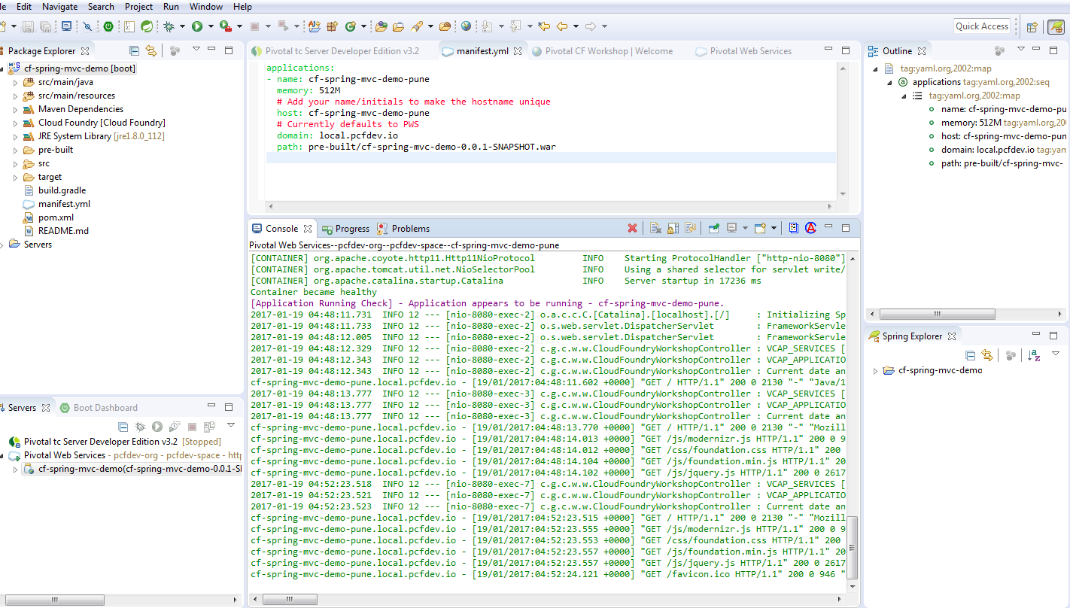

Step 2: See the application has been deployed successfully

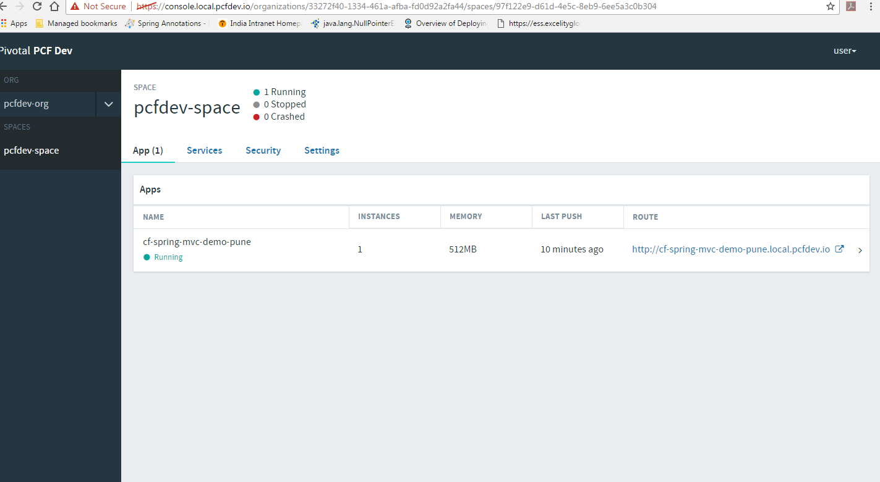

Step 3: Application Information Displayed successfully.

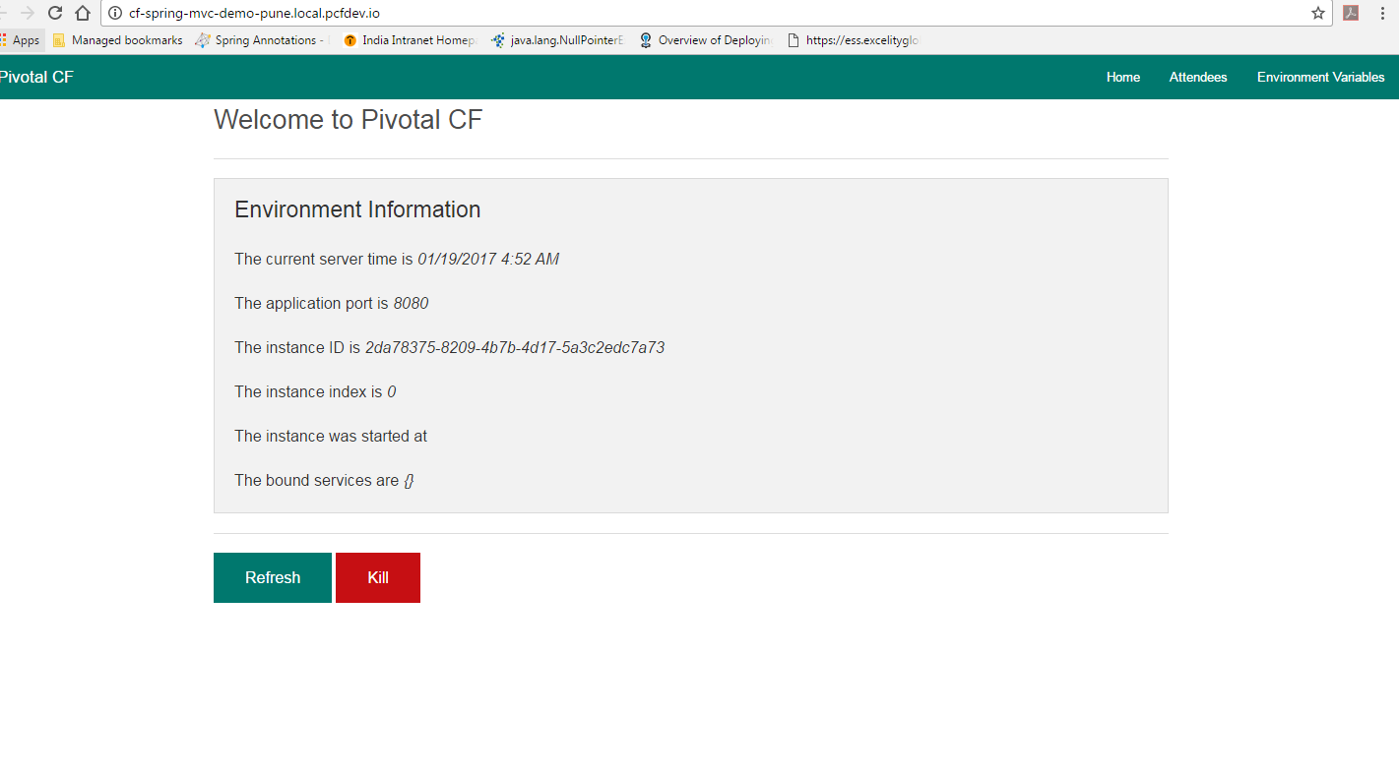

**Step 4:** Scaling the applications (See the highlighted Arrow in below screen)

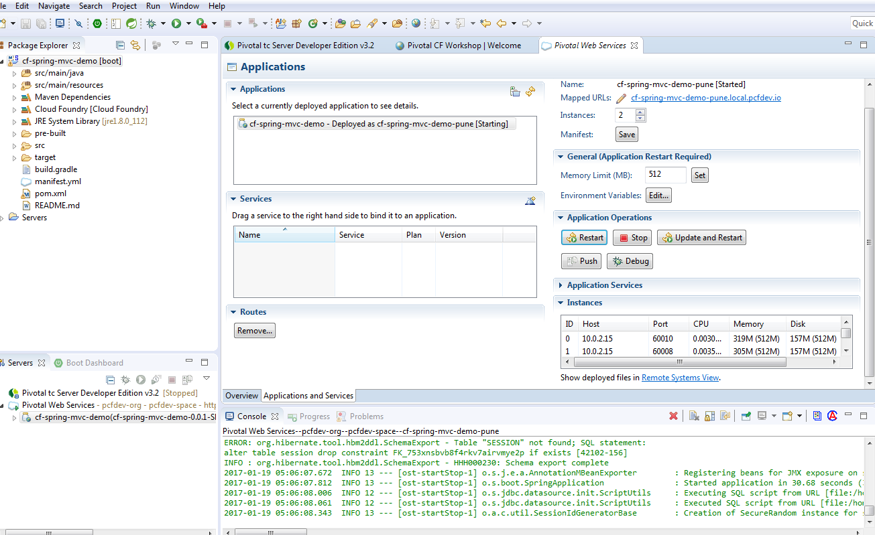

**Step 5 :** Prompt YAML File changes(please, See highlighted Pointer).

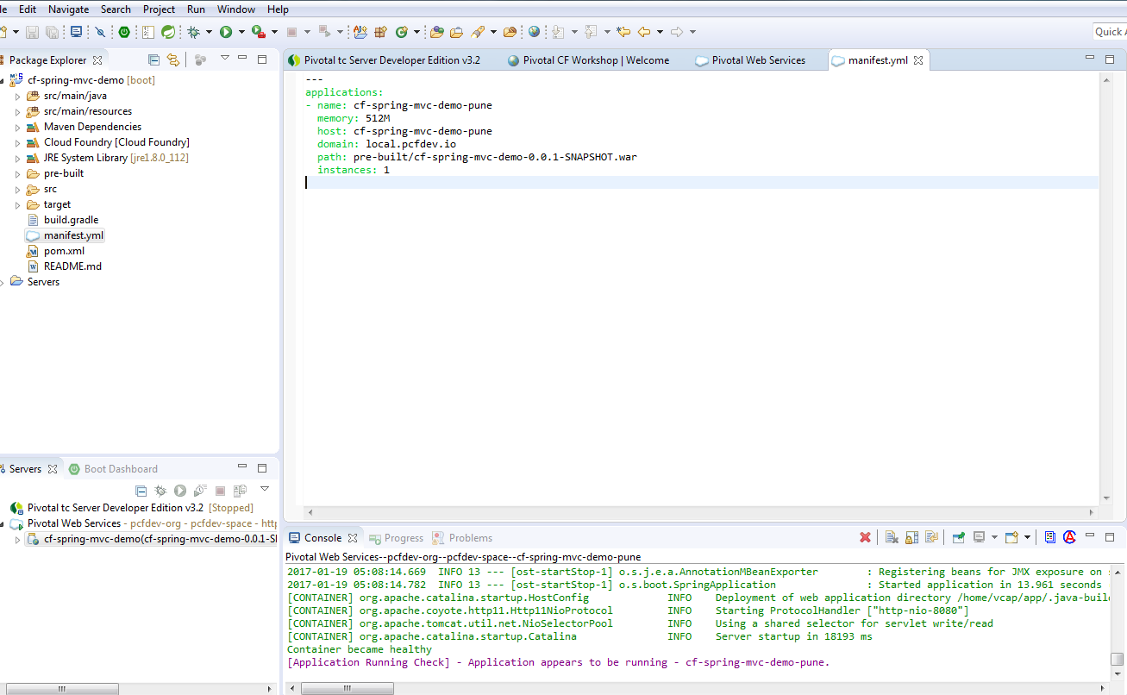

**Step 6:** Changes in Memory form 512 to 128 which is insufficient (please, see Highlighted pointer)

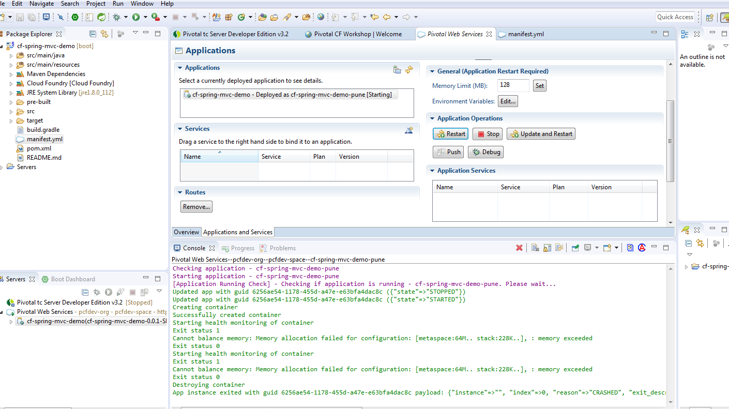

**Error**: Cannot balance memory: Memory allocation failed for configuration: [metaspace:64M.. stack:228K..], : memory exceeded.